1.Draw a simple network diagram showing three devices (like your laptop, a friend's phone, and a smart TV) connected to a switch, and label which device is in which VLAN (e.g., VLAN 10 for streaming, VLAN 20 for personal devices).
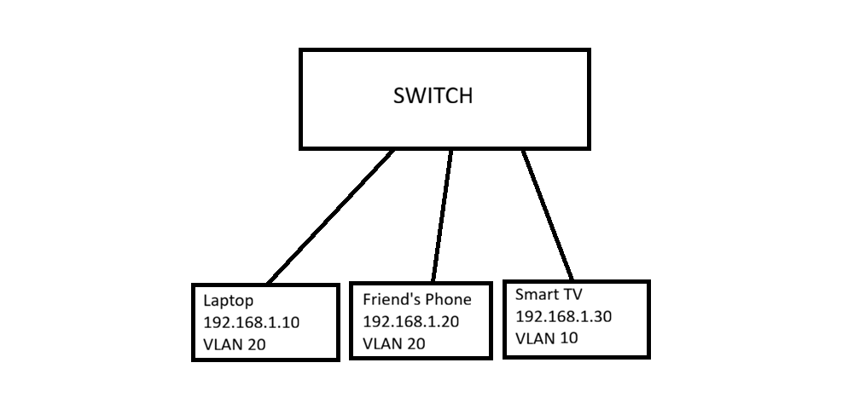
2.Configure a simulated switch using Cisco Packet Tracer or NetSim: create two VLANs (VLAN 10 and VLAN 20), assign three PCs to VLAN 10 and two PCs to VLAN 20, and verify that PCs in different VLANs cannot ping each other.<br><br><em><strong>Hint:</strong> Use the 'vlan' and 'switchport access vlan' commands in the simulator CLI.</em>
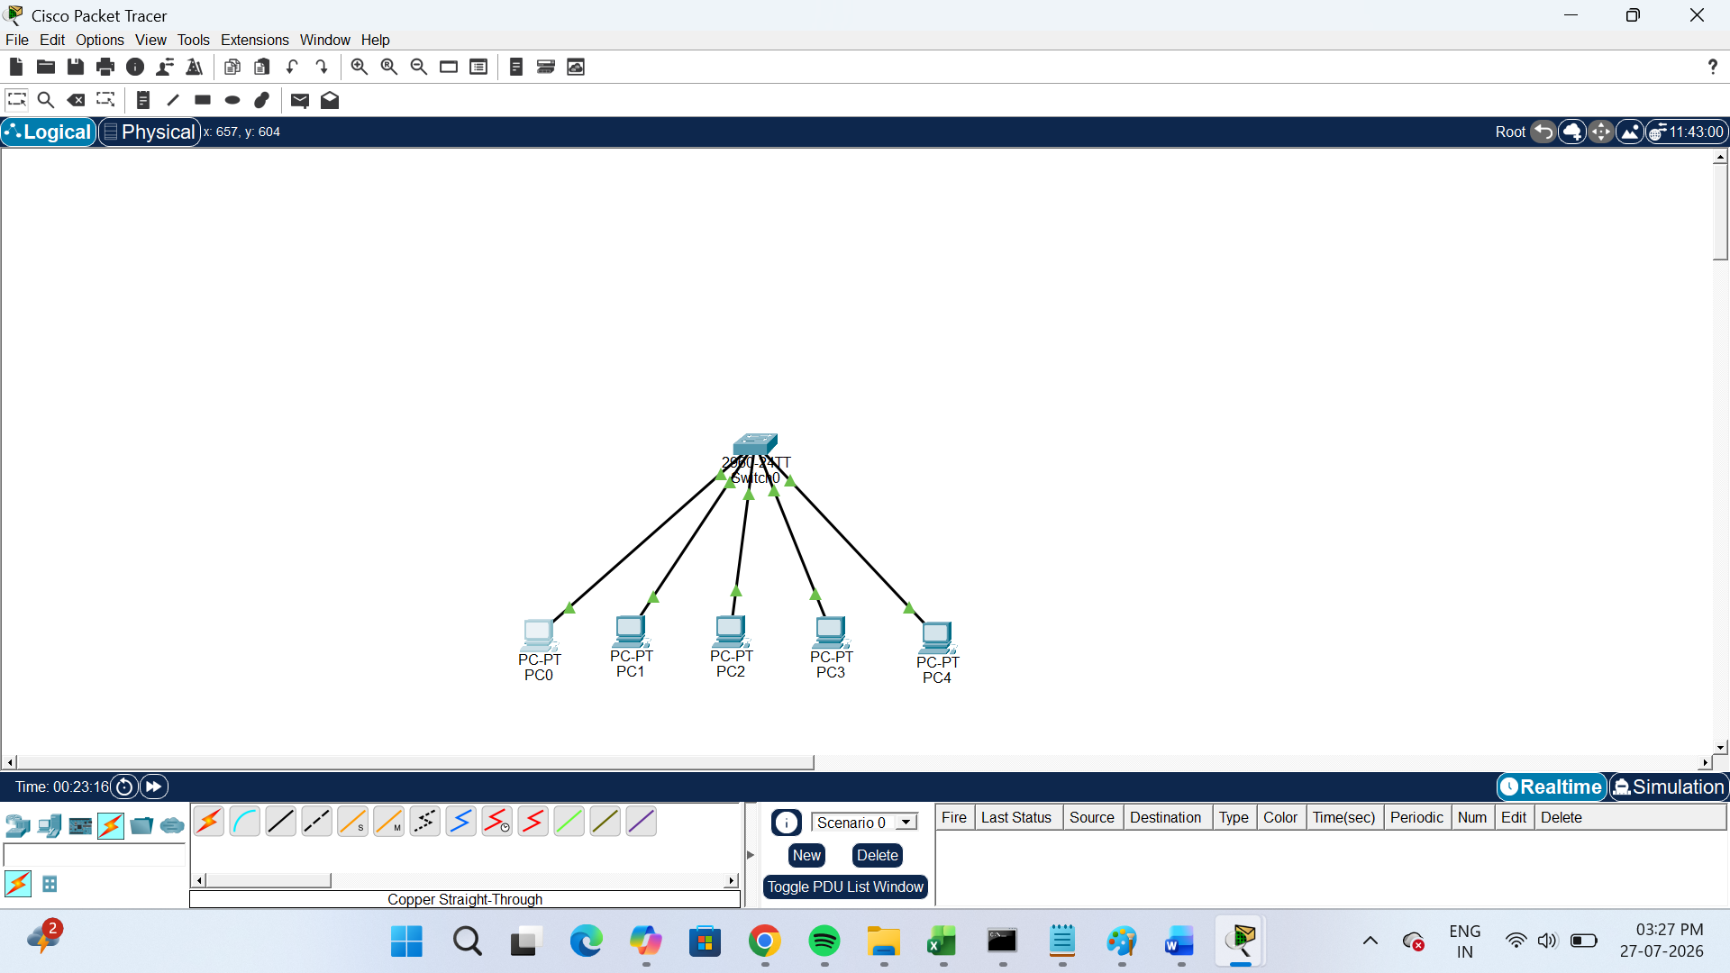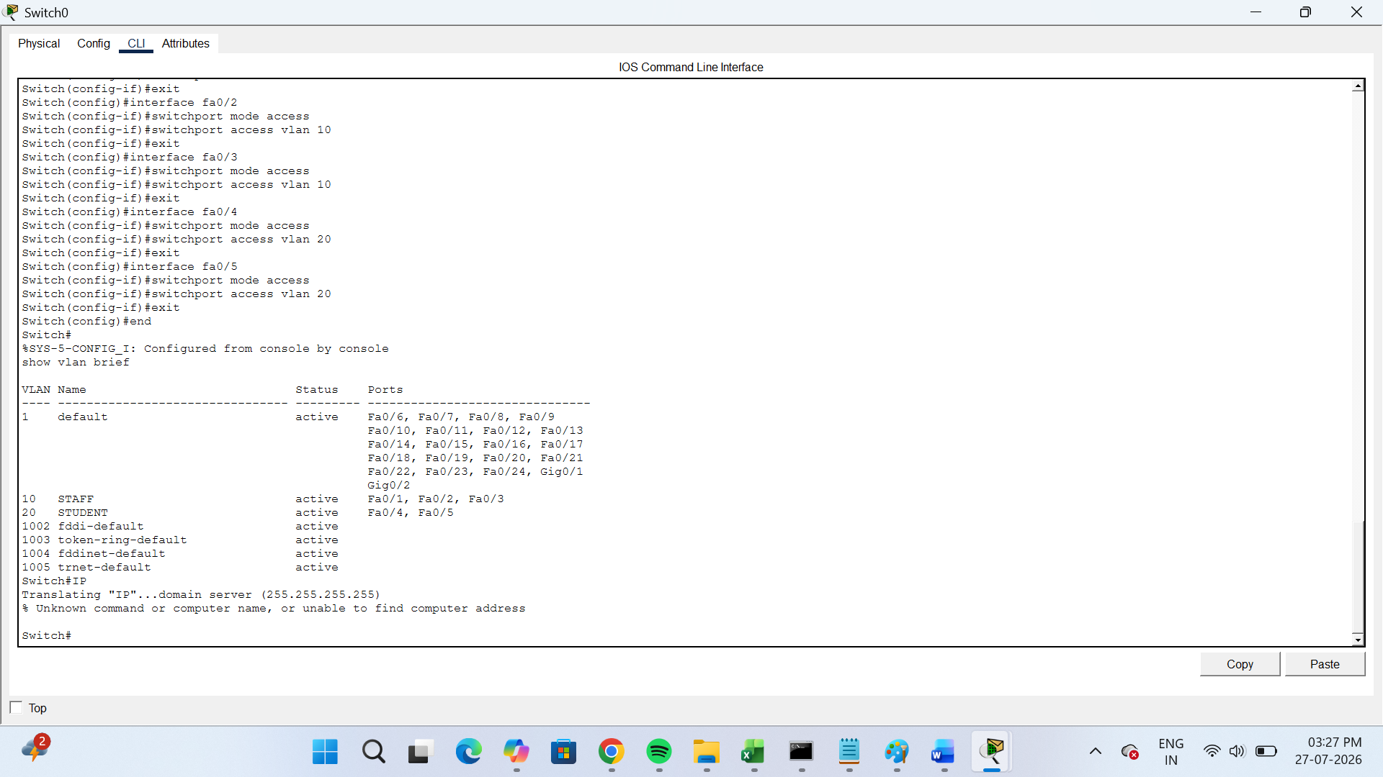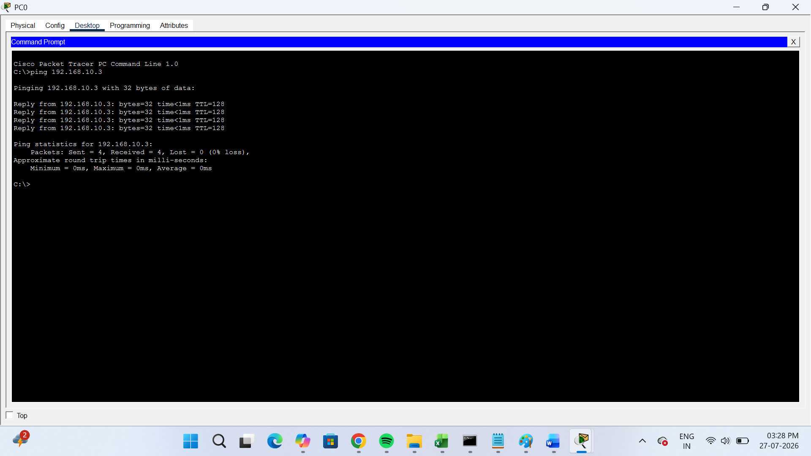
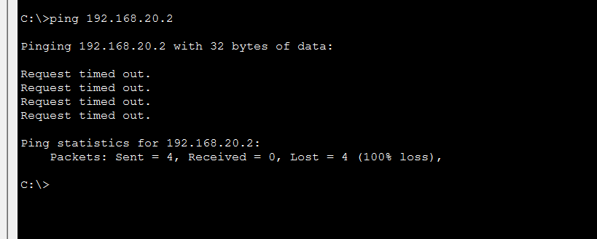
3.In any network simulator, set up a scenario where you move a PC from VLAN 10 to VLAN 20. Show the before and after configuration commands and test connectivity to confirm the change.
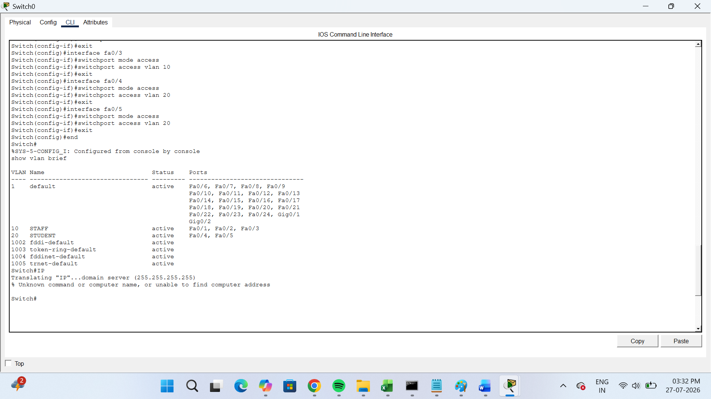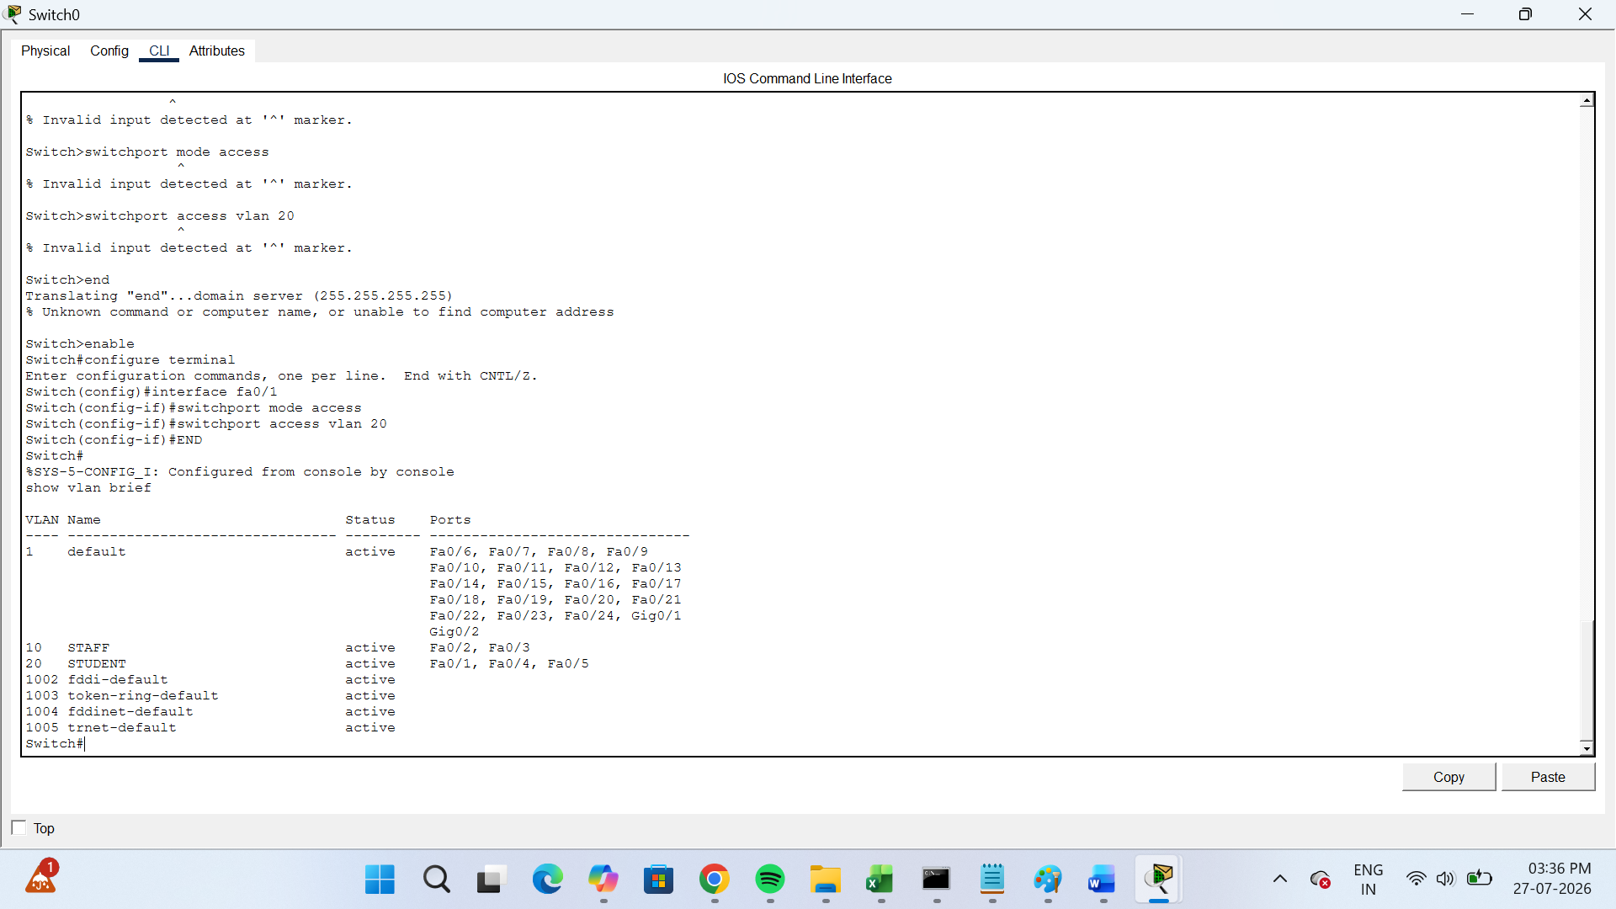
4.Write a short script or command list that would automate assigning 10 ports on a switch to VLAN 30, using the syntax of your chosen simulator (Packet Tracer, NetSim, or GNS3).<br><br><em><strong>Constraint:</strong> Use a loop or range command if supported by the tool to avoid repeating the same command 10 times.</em>
->Switch> enable
Switch# configure terminal
Switch(config)# interface range fastEthernet 0/1 - 10
Switch(config-if-range)# switchport mode access
Switch(config-if-range)# switchport access vlan 30
Switch(config-if-range)# exit
Switch(config)# end
Switch# write memory

